Garage Door Top and Side Weather Seal Installation

SAFETY FIRST!
First Rule for any garage door repair:
UNPLUG THE DOOR OPENER
Put the door in manual operation by pulling the release.
Next, clamp the door in place, either up or down depending on the task, using vice grips, one on each side of the door.
Never neglect these basic rules when working on any garage door. Accidental operation of the door while it is under repair can be fatal.
Tools Required:
Hack Saw, Utility Knife with a sharp blade, T or try Square, pencil, hammer, calk and calk gun.
With the garage door unplugged and clamped in the open position, measure the width of the opening at the top of the opening where the door seal will be nailed.
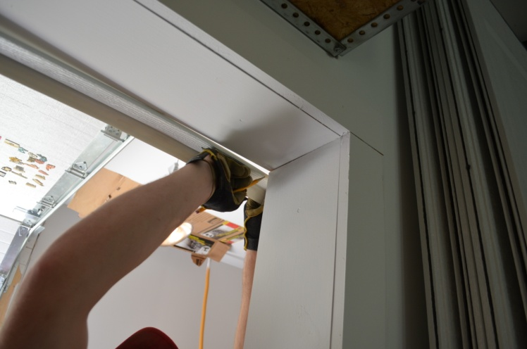
Getting the top piece cut to the proper length is the greatest challenge in this easy to do project. Here a helper is a big plus. One way of doing this is to temporarily nail one end to the seal in place and add a few more temp nails along the width of the seal so you can hold the other end up and mark it for cutting. The seal is a bit cumbersome when it comes to the top piece so take your time and be sure to get it cut to a nice tight fit.
Square cut the PVC, do not miter and use the utility knife to cut the vinyl flap the same length as the PVC portion of the weather seal.
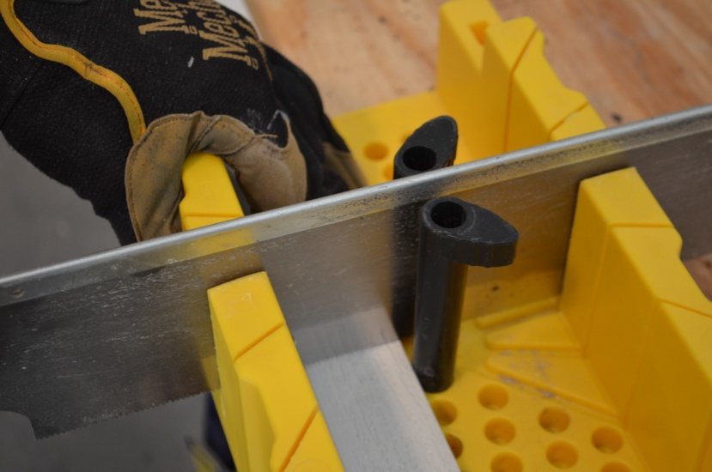

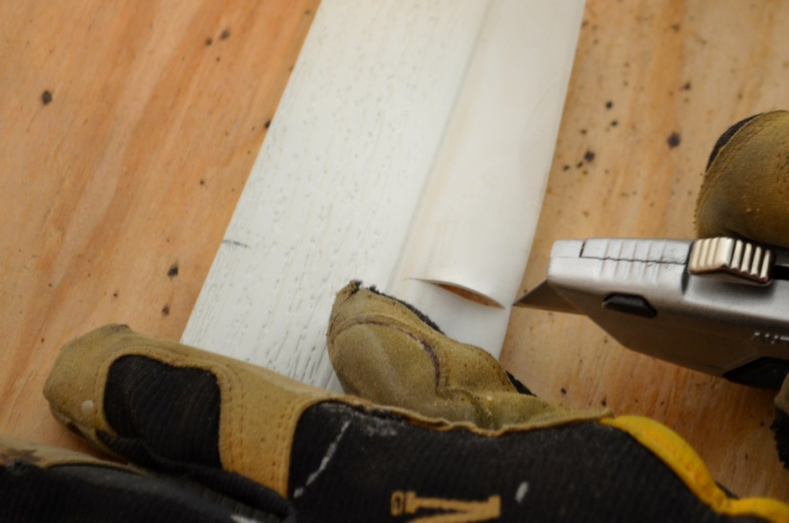
Now temp nail the top seal to the jamb, you want the inside edge of the PVC portion to be even with the inside edge of the jamb. Put enough temp nails in to hold the seal up against the jamb.
Now measure and cut the side pieces. Setting the inside edge of the PVC flush with the inside of the door jamb just as you did with the top piece, temp nail the two sides in place.

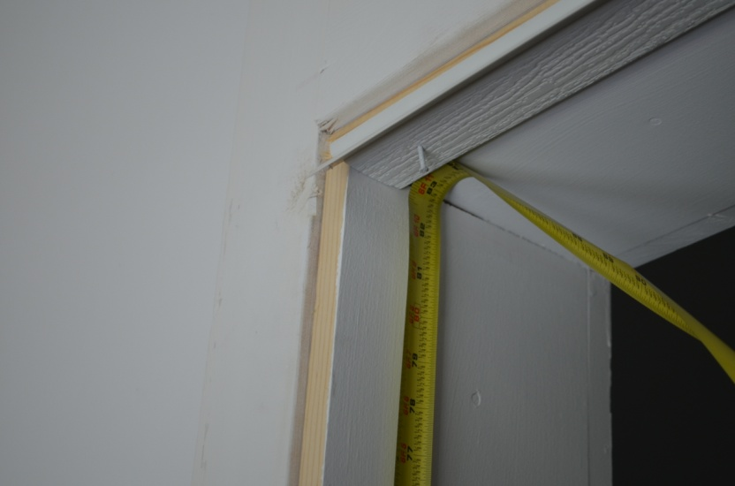

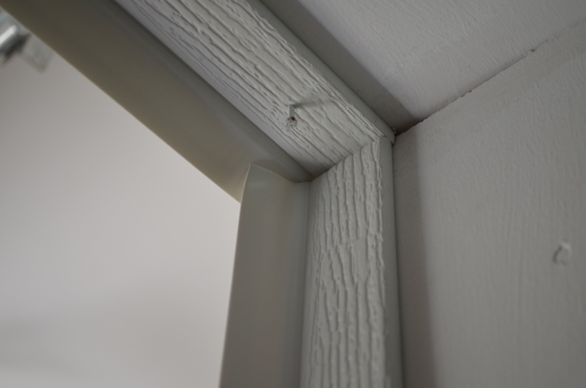

Remove the clamps, close the door and re clamp the door closed tightly to the floor.
Now it is time to set the weather seal in place. No part of the PVC portion is to touch the garage door, just the vinyl is to contact the door. You want the vinyl to form a J shape to the door, not a 90 degree angle. Temp nail top and sides. Remove clamps and open and close the door a few times, by hand to be sure that the weather seal is not impeding the garage door in any way. Once this has been checked out, close and clamp the door down and set the nails.

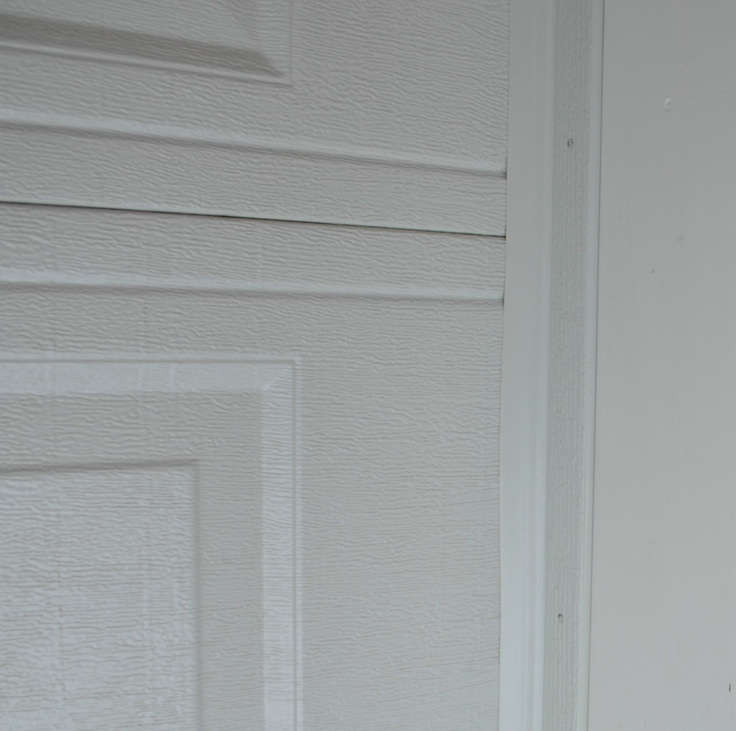

Typically 6” to 8” spacing between nails is sufficient. Do not nail through the PVC without pre drilling when you are within 4” of the end of the PVC, pre drill there, otherwise no pre drilling is needed, you can nail right through the PVC. The exception to that is in extreme cold, pre drill all in extreme cold.
Now using a good quality colored calk, calk at the leading edge of the PVC where it meets the jamb. This will prevent air from getting in under and behind the weather seal. We also run a bead of calk at the point where the top meets the sides and also on the bottom of the sides at the floor.

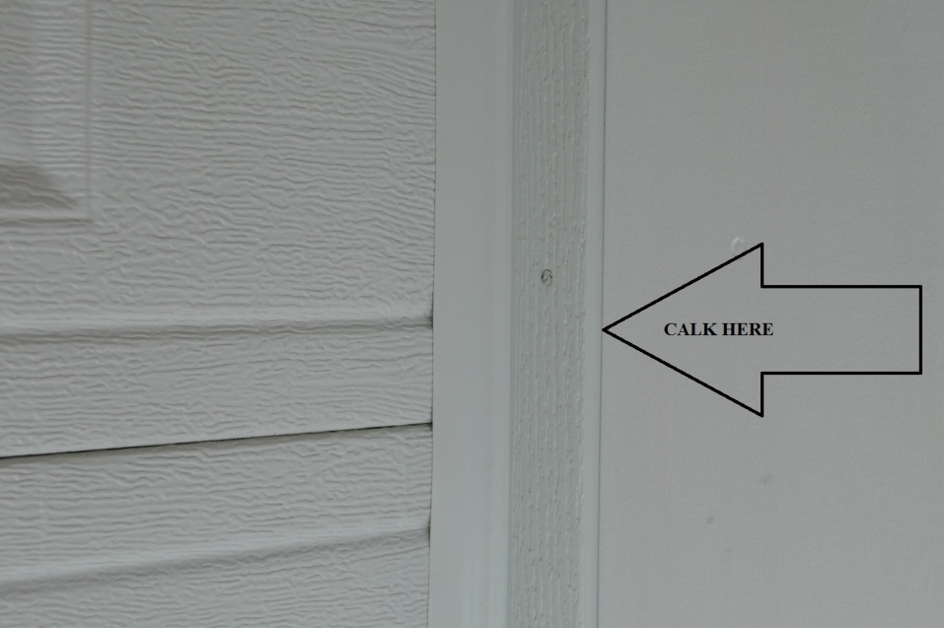

Until the weather seal takes it’s “set” make sure that the vinyl flap is lying against the door when the door is down and check it every time you close it for a week or so depending on the temp’s and if the door gets sunlight. It is recommended to leave the door closed for a few days if possible, this will allow the vinyl flap to acquire the correct form and should maintain that form and not become an issue.
A little diligence in keeping an eye on this for a time will pay off in the long run, once that vinyl has “set” no need to pay it any attention.
Once you have completed all of the above, re attaché the opener, plug the opener back in and cross this one off you’re to do list!

